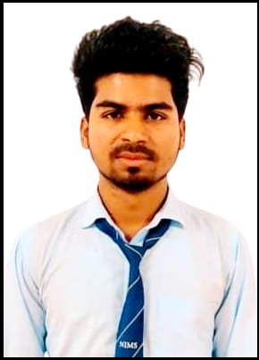 SHAHNAWAZ SAHKIB

## 📧siddiquishakib983@gmail.com

📞 +91-9508436024 : <https://github.com/shahnawazshakib786>

LinkedIn: <http://www.linkedin.com/in/shahnawazshakib8963>

# OBJECTIVE

# B.Tech Computer Science student at NIET, Jaipur. Skilled in IT support, project management, and technical troubleshooting. Strong in communication, problem-solving, and leadership, aiming to contribute to a dynamic organization.

# TECHNICAL SKILSS

**Programming Languages** JavaScript, Python

**Frontend Technologies** HTML5, CSS3, Bootstrap, React.js

**Framework & Libraries** React.js, Next.js, NumPy, Pandas, Matplotlib

**Database** SQL, MongoDB

**Tools & Technologies** GitHub, Microsoft Excel (Pivot Tables, VLOOKUP, Data Validation), Power BI, SQL Server

**Soft Skills** Critical thinking, Problem Solving, Leadership

**Coursework** DBMS, Operating System, Computer Network, DSA

# EDUCATION

**NIMS UNIVERSITY** July 2021 - June 2025

Bachelor of Technology in CSE **CGPA: 7.62**

**MAHATMA GANDHI COLLEGE** May 2019– February 2021

Senior Secondary (Class XII) **Percentage: 71.6**

**MUKUNDI CHOWDHRY HIGH SCHOOL** March 2019

Secondary (Class X) **Percentage: 61.4**

# CERTIFICATIONS

**Python for Data Analysis-Udemy** [**View**](https://drive.google.com/file/d/1U88abTlDo1PLc6jeqe33F-apgDbLrNET/view?usp=drive_link)

* Covered data manipulation, visualization, and statistical analysis using Pandas, NumPy, Matplotlib, and Seaborn.
* Hands-on experience in data cleaning, EDA, and automation.

**Power BI Data Analysis-Udemy** [**View**](https://drive.google.com/file/d/1l38mLI3OrdLpT0IyIBNvIPM6CMW-mhZB/view?usp=drive_link)

* Proficient in creating interactive dashboards and reports.
* Experience in data modelling, DAX functions, and Power Query for data transformation.
* Hands-on experience in connecting, cleaning, and visualizing data from multiple sources.

# PROJECTS

**Zomato Data Analysis Project |** [GitHub](https://github.com/Ashishydv143/job-portal-1)

* Cleaned and processed **100%** of the dataset using **Pandas & NumPy**, handling missing values and outliers.
* Conducted **EDA**, identifying trends in restaurant ratings and pricing, improving data insights by **40%**.
* Created **10+ visualizations** using **Matplotlib & Seaborn**, enhancing data presentation clarity by **60%**.

**In Depth Analysis of Company's Revenue |** [**Link**](https://github.com/shahnawazshakib786/In-depth-analysis-of-company-s-revenue/blob/main/In%20depth%20analysis%20of%20company's%20revenue.ipynb)

* Cleaned and processed **100%** of financial data using **Pandas & NumPy**, ensuring accuracy in analysis.
* Conducted EDA, identifying revenue trends and growth patterns, improving financial insights by **45%.**
* Created **10+ visualizations** using **Matplotlib & Seaborn**, enhancing data-driven decision-making by **55%**.